Allete Firm Report
Kelsey Taylor
Mitchell Shea
FIN 422
Dr. Schrenk
12/8/16

Basic Information
Allete, Inc. is an energy company based out of Duluth, Minnesota. The company is involved in the generation, transmission, distribution, and marketing of electricity. It is traded on the New York Stock Exchange with the ticker symbol of ALE. Allete is in the utilities sector and diversified utilities industry. Allete’s current market capitalization is $3.02 billion. After extensive research and valuation, we recommend buying Allete’s stock.
Investment Summary
Allete, Inc. consists of 6 segments: Allete Clean Energy, Allete Renewable Resources, BNI Energy, Minnesota Power, U.S. Water, and Superior Water, Light, and Power.
On November 18th, U.S. Water Services acquired Water and Energy System Technology (WEST), a company that provides specialty chemical and engineering services for water treatment. This is significant because it expands both U.S. Water Services and Allete’s footprint into the southern California market. This acquisition supports Allete’s strategy of supporting the growth of U.S. Water Services through organic growth as well as acquisitions. It also demonstrates Allete’s focus on energy generation through renewable resources such as water. Additionally, the recent acquisition demonstrates the company’s overall strategy to deliver a sustainable future for the industry, their customers, shareholders, and nation.
Another major recent development is that a new chief financial officer, Bob Adams, was appointed on October 25th of this year. This change will be effective March 4th of 2017. Adams has been with the company since 1982 and held the position of Senior Vice President - Energy Centric Businesses, Chief Risk Officer until this promotion.
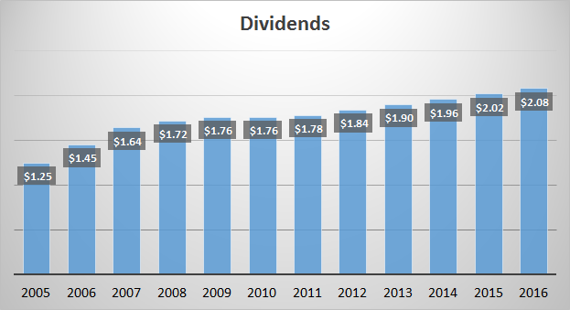
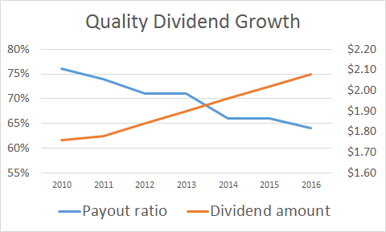
Allete’s growing EPS and declining payout ratio allows Allete to better align dividend growth with earnings growth. Allete’s target EPS minimum growth rate is 5%. The company strives to provide long term earnings growth. One way they plan to do this is investing in energy infrastructure because even if it is costly in the short term, it will help the company be more efficient in the long run. Annual dividends have been paid consecutively since 1948, and the annual dividend has increased each year since 2010.

Allete is underpriced because their EBITDA is artificially lower than competitors due to Allete’s significant production tax credits. When comparing EPS and revised EPS for 2013, 2014, and 2015, the difference between these two figures is increasingly larger each year. In 2013, revised EPS was 0.46 larger, in 2012, it was 0.52 larger, and 0.76 higher in 2015. This proves that the production tax credits are having an increasing effect on Allete’s EPS as well as other figures that EBITDA influences.
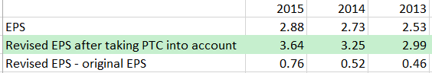
Business Description
Allete, Inc. consists of 6 segments: Allete Clean Energy, Allete Renewable Resources, BNI Energy, Minnesota Power, U.S. Water, and Superior Water, Light, and Power. Allete Clean Energy specializes in developing, acquiring, and managing clean and renewable energy projects. Allete Renewable Resources operates and maintains wind generation facilities in North Dakota. BNI Energy owns and operates BNI Coal, LTD., which is a lignite mine in North Dakota. BNI Coal, LTD. sells their energy to two electric generating companies, Minnkota Power and Square Butte. Minnesota Power provides electricity to approximately 144,000 residents, 16 municipal systems, and some of the nation’s largest industrial customers. Many of these large industrial customers are located in the iron range and are involved in the domestic steel industry. U.S. Water Services is an integrated industrial water management company. The company is based out of St. Michael, Minnesota and serves numerous industries including biofuels, power generation, midstream oil and gas, and health care. As mentioned previously, U.S. Water Services recently acquired a specialty chemical and engineering service company named Water and Energy System Technology (WEST). Lastly, Superior Water, Light, and Power provides regulated electric, natural gas, and water service in northwest WI. Their customer base includes 15,000 electric customers, 12,000 natural gas customers, and 10,000 water customers.
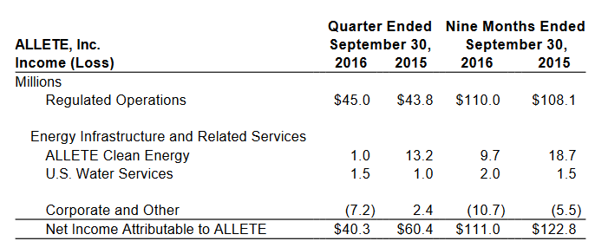
Allete’s revenue mainly comes from their regulated operations, including Minnesota Power, Superior Water, Light, and Power, and an investment in American Transmission Company. American Transmission Company is a Wisconsin based regulated utility company that owns and maintains electric transmission assets in the upper midwest including Wisconsin, Minnesota, Michigan, and Illinois. Main expenses come from fuel and purchased power as well as maintenance and operating. Much of this maintenance is required through different regulations and policies.

Management and Governance
The chairman, president, and chief executive officer of Allete is Alan R. Hodnik. He has been the Director of Allete’s board since 2009, and been with the company since 1982. In 2015, he earned $571,092 in bonuses and $585,676 in base pay along with $946,768 in stock award value. The significant amount of bonus and stock options proves that Hodnik has much incentive to make decisions in the company’s best interest and help it perform as well as possible. While this is positive, the amount of stock award value he received may also make performance his motives questionable. Because of the significant amount of stock award value, there is potential motivation for Hodnik to only focus on getting the stock price as high as possible in order receive as much money as possible and not consider how decisions may negatively affect the company overall. While being the president, CEO, and director may help communication between the board and officers, it may also be granting one person to much power. Hodnik is the only person to hold both an officer and board of director position.
The senior vice president and current chief financial officer of Allete is Steven Q. DeVinck. Before joining the company in 1997, he was educated at the University of Wisconsin - Superior and then was chief accountant for Enbridge Energy. DeVinck is very familiar with the area because of his choice to attend UW Superior and is also very familiar with energy and utility businesses because of his background with Enbridge Energy. These facts prove that he is highly qualified for the current positions he holds.
Industry Overview and Competitive Positioning
The utility industry is evolving from a few monopolies controlling it to several separate companies controlling various shares of it. Utilities will always be necessary wherever the business is, and are especially necessary in the midwest where Allete’s customer base is mainly located. This is due to the harsh winters and hot, humid summers that the midwest typically experiences. Demand in the midwest can vary if it is a warm winter or cool summer, however.
Under the Obama administration, regulations drastically increased in the utility industry. Most of these regulations dealt with trying to eliminate as many emissions as possible. Eliminating emissions requires significant investments for the utility companies, and are very burdensome. The utility industry is currently uncertain about which regulations will stay the same and which will change under the new President.
There are several trends occurring in the utility industry. The utility industry as a whole is becoming more consumer focused. Instead of viewing consumers as different sections of “ratepayers”, utility companies are starting to emphasize focusing on individuals. Companies are trying to set themselves apart by helping consumers use energy more efficiently through tips on consumers’ bills, different apps, and better energy infrastructure. Allete is regularly upgrading its energy infrastructure in order to ensure that their consumers’ power supply is not interrupted and is efficient as possible.
Allete has a large advantage over competitors when it comes to the price they charge consumers. Specifically, Minnesota Power’s average rates for the past several years have been among the lowest in the Edison Electric Institute’s West North Central region, which spans over six states from North Dakota to Missouri. Having competitively priced rates helps both Allete and Minnesota Power, maintain their current customer base while also attracting new customers.
The U.S is continually shifting to natural gas for power generation. In 2016, natural gas production will outpace coal production for the first time and is projected to account for 34% of the total U.S. utility scale electricity generation.
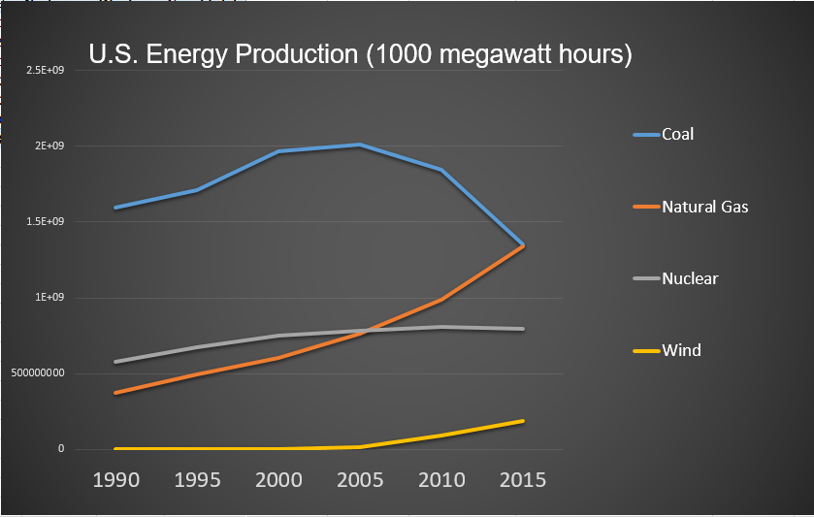
Because of this increase, it is likely that the natural gas price trends will increasingly influence electricity prices in the future. This could potentially become a problem for the industry if the price of natural gas becomes more volatile. If the price of natural gas increases, Allete will be in a good position with their proportionally higher renewable energy production compared to other power companies across the United States. If natural gas prices increase to the high prices seen in 2008, Allete will be in a position to produce energy for less than many of their competitors while having the ability to charge more per kilowatt hour to their customers to keep pace with their competitors. The EIA predicts that the price for natural gas will increase from an average of $2.50/million British thermal units MMbtu in 2016 to $3.12 (MMbtu) in 2017. This is largely thanks to higher domestic consumption supplemented with higher exports of natural gas. The NYMEX future contract values for 2017 suggest that the Henry Hub natural gas price could range anywhere from $2.01/ MMbtu to $4.84/MMbtu in 2017. The higher natural gas prices could likely lead to higher profit margins for Allete.

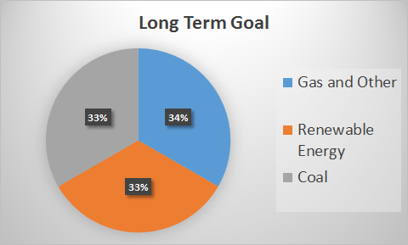
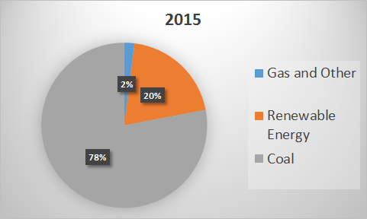

Valuation
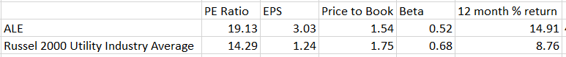
Allete’s stock has performed exceptionally well over the past five years. Before adjusting the EPS for production tax credits, Allete’s P/E ratio has been fairly high compared to other competitors, which causes some to believe Allete is somewhat overvalued. Through thorough research of the company’s annual report, we found that Allete receives a significant amount of money in the form of production tax credits from the federal government. Although it is uncertain whether Allete will keep receiving tax credits under the new President, Allete will at least receive this tax credits through the remainder of the year. Before adjusting for the tax credits, Allete’s P/E ratio would average 18.55 for 2013-2015, after adjusting the P/E ratio for the tax credits the P/E ratio would have averaged 15.33 over the same time period. Our projected P/E ratio for 2016 after adjusting for tax credits is 14.2 and without making any adjustments our projected P/E ratio is about 18.7. After adjusting for production tax credits, Allete’s stock appears to be trading at a reasonable value compared to the average P/E of the Russell 2000, which is currently 19.55.

Financial Analysis
Allete’s dividend yield is 3.3% compared to the S&P 500 with a dividend yield of 2.12% and the Russell 2000 which has an average dividend yield of 1.5%. Allete’s dividend yield of 3.3% would pass Ben Graham’s stock screen of dividend yield being no less than two-third of the AAA corporate bond yield. Moody’s AAA corporate bond yield was 3.41% at the end of September. Using Moody’s estimate, Allete’s dividend yield is 96% of the AAA corporate bond yield. Moving forward, interest rates are likely to increase along with AAA corporate bond yields, it is likely that Allete will be able to keep pace by increasing dividends as they previously have.
Our calculated return on invested capital for 2015 was 4.33%. This figure is higher than our estimated current WACC of 3.35%. The return on capital is slightly lower than an ideal return, but Allete acquired 87% U.S. water services for $168 million, and made just over $618 million in total investments in 2015. Allete is constantly looking to acquire profitable businesses and enter new markets, they just recently purchased Water & Energy System Technology (WEST) located in South Western U.S. The result of Allete’s acquisitions is a lower current ROIC, but will result in higher earnings in the future. Allete’s long term focus makes them an attractive investment.
Allete holds long term, full requirement contracts with their large industrial consumer base. Because of this, their income and revenues will continue to be steady for the foreseeable future. Of all the contracts Allete holds, the earliest termination date is August 31, 2020 and the latest is December 31, 2031. Allete requires all new contracts to have a ten year minimum along with a four year cancellation notice requirement. These long term contracts provide Allete with guaranteed revenue for the contract life and the cancellation notice requirement gives Allete four years to find new business to take the place of the cancelled contract.

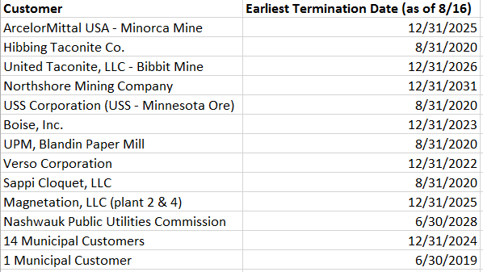
Allete’s large industrial customer base is primarily located in the Iron Range and therefore includes some of the world’s largest known reserves of taconite, copper-nickel, and other precious metals. The taconite business does tend to be volatile, but these large industrial customers’ primary market, the domestic steel industry, remains competitively strong and continues to benefit from increasing automotive sales and strengthening industrial activity.
Performance
Allete has performed quite well over the last five years. Allete has increased about 16% annually while the Russell 2000 has increased about 12% annually over the last five years.
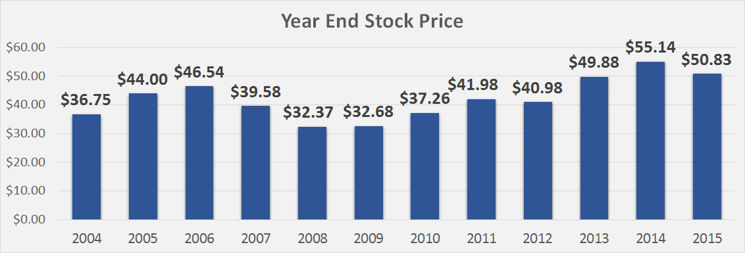

Investment Risks
Allete is subject to many environmental policies and other regulations that have substantial effects on current and future business. These policies and regulations try to control air and water quality, waste management, along with other environmental impacts. New or updated policies and regulations can not only cause companies such as Allete to make significant investments over an extended period of time, but can also force these companies to pay fines if they do not comply by certain deadlines.
A potential investment risk derives from the fact that Allete is dependent on third parties transmitting and distributing the power that Allete generates. If any infrastructure of the third party fails, it could interrupt the delivery of electricity to Allete’s customers. If the third party’s transmission capacity is less than the amount of energy Allete is providing them with, Allete could lose money.
An additional investment risk surrounds Allete’s and specifically Minnesota Power’s relatively limited customer base. If one of the customers cancels their contract or experiences a downturn, it has the potential to have a substantial impact on Allete. However, the company would have time to prepare for this impact because of the four year cancellation notice requirement.
Allete attempts to counteract investment risks associated with the company by having a diversified power generation portfolio through coal, hydro-electric, biomass, wind, and eventually, natural gas. Allete is consistently working to diversify its power generation, especially through renewable projects. For example, Allete Clean Energy finalized the purchase of a wind generation facility in Iowa towards the end of 2014.
Even after taking the potential investment risks into account, Allete’s strengths and opportunities still outweigh the risks and we therefore recommend buying Allete at its current price.

