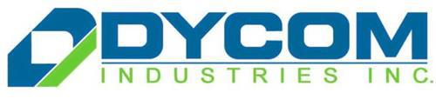

Equity Report

Andrew Glockner
Zachary Harris
Nick Campion
Darien Timmerman

Business Description

Dycom (DY) completes wireless network construction projects from remote cell sites to massive sports venues. They provide the physical infrastructure and technology to add capacity and eliminate gaps in telecommunication coverage. Dycom offers several services to customers such as full macro cell construction, small cell infrastructure deployment, distribution of antenna systems as well as installation and monitoring of those systems. Dycom also completes complicated buried and underground telecom wire construction. They install new plant and maintain existing plant using time tested methods and technologies. Lastly, Dycom completes multifaceted aerial telecom construction projects, from constructing new plant to moving existing plant or setting new structures.

Basic Information

Dycom has a market cap of $3.22 billion and a current stock price of $109.19. They predominantly focus on the telecommunications industry within their work. One major advancement set to take place around the year 2020 is the introduction of 5G service. This introduction of 5G service into the telecommunications industry is expected to have a very large impact on companies that conduct work within that industry. In the past there has been a very similar situation which took place in 2010, and that was the introduction of 4G service into the industry. After the integration of 4G service in 2010 the stock price of Dycom was hovering around $10 per share, and there was little initial impact on the stock price with the integration of the 4G service into the industry.
Figure 1:
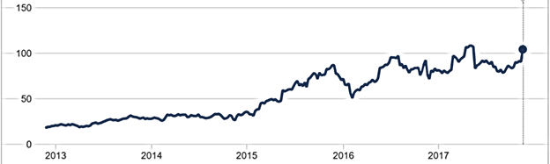

Figure 1 above shows stock price for Dycom after the impact of 4G was fully felt. When you look at this chart you see that there are four major trends. The first trend occurs from 2013 to 2015, Dycom shows little to no growth at all. This was because the telecommunications industry was not that involved with the company yet. Second, in 2015 Dycom stock went from $28 to $78. Dycom experienced this growth because this was when the telecom giants were motivated to expand their networks to reach as many customers as possible. Dycom was quick to participate in large 1 GBPS (gigabits per second) rollouts, and they also secured many multi-year contracts with customers during this time which was beneficial for their business. Third, the end of 2015 to the start of 2016 Dycom had a massive downward trend. This downward trend was because Alphabet announced that they were going to suspend their services in eight major cities, at the time Alphabet was a big customer of Dycom. Lastly, there was a massive selloff in the third quarter earnings report, Dycom stock fell over 20 percent. Surprisingly Dycom beat the streets expectations on the top and bottom line. Although, in the conference call management said that they had low future expectations for Dycom in quarter four for the top and bottom line. Dycom reported 2017 quarter four earnings recently and beat street expectations in all aspects and the stock gained over 10 percent. Dycom management takes great pride in beating the streets expectations and they hope to continue surpassing expectations in the future.

Management & Governance

Dycom is committed to sound corporate governance and full compliance with the New York Stock Exchange, Securities and Exchange Commission and other regulatory and legal requirements. The Board of Directors has adopted governance policies, procedures, and written charters for each of its Audit Committee, Compensation Committee, Corporate Governance Committee and Finance Committee which form the governance framework for Dycom.

Executive Officers

Steven E. Nielsen
President and Chief Executive Officer
Timothy R. Estes
Executive Vice President and Chief Operating Officer
H. Andrew DeFerrari
Senior Vice President and Chief Financial Officer
Richard B. Vilsoet
Vice President, General Counsel and Corporate Secretary
Kimberly L. Dickens
Vice President and Chief Human Resources Officer

Steven E. Nielsen has been the Company's President and Chief Executive Officer since March 1999. Prior to that, Nielsen was President and Chief Operating Officer of the Company from August 1996 to March 1999, and Vice President from February 1996 to August 1996.

Board of Directors
Stephen C. Coley
Former Management Consultant with McKinsey & Company Inc.
Dwight B. Duke
Senior Corporate Vice President/President of Scientific-Atlanta Inc.
Eitan Gertel
Former Chief Executive Officer of Finisar Corporation and former Chief Executive Officer and Chairman of the Board of Optium Corp.
Anders Gustafsson
Chief Executive Officer and director of Zebra Technologies Corporation and former Chief Executive Officer of Spirent Communications plc.
Patricia L. Higgins
Former President and Chief Executive Officer of Switch & Data Facilities Company, Inc. Former Chairman and Chief Executive Officer of The Research Board and former Chief Information Officer of Alcoa Inc.

Steven E. Nielsen
Chairman of the Board
Laurie J. Thomsen
Co-founder and former General Partner of Prism Venture Partners. Former General Partner of Harbourvest Partners.

Industry Overview and Competitive Positioning

Customers

Dycom’s largest customers in order are AT&T, CenturyLink, Comcast and Verizon. All of these major Dycom customers are moving forward with their 5G wireless rollout plans coming in 2020. Thus far, Verizon is showing the most potential with 5G for Dycom, as they have a major wireline deal in place covering most of the East Coast. On top of this deal, Dycom has made several acquisitions of construction engineering companies around the United States to bolster their ability of underground fiber-optic cable construction.
Despite all of these major customers being wireless telecommunication companies, they do require substantial wireline investment to take fiber-optic cables to their cell towers. When it comes to the fiber construction business, Dycom is five times larger than their next competitor. With that being said, there is great confidence that their customers will need significant wireline deployment with the rollout and growth of 5G and also the continued support of 4G. As stated, AT&T is their largest customer, so a potential wireline deal with them could result in huge success for Dycom.

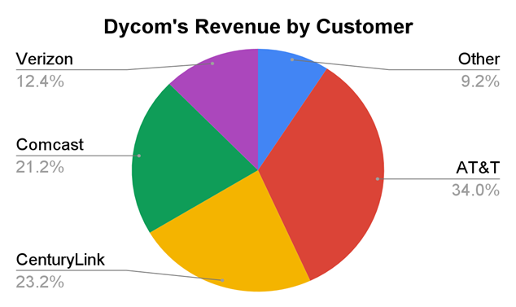

This chart the shows the representation of Dycom’s revenue by customer. AT&T is credited with over one-third of Dycom’s revenue. Verizon, who Dycom has a major wireline deal with, is responsible for over 12% of their revenue. The “other” category is companies making up smaller portions of revenue, such as, Windstream and Google.

There are some concerns that the 5G wireless rollout could slow wireline investment by their customers, but there were similar concerns when 4G LTE came out. In that situation, Dycom customers needed fiber cables taken to thousands of cell towers and that rollout did not result in any cannibalization of wireline investment. The need for fiber-based solutions will be bigger than it was for 4G LTE. Additionally, 5G will be much more reliant on a fiber network than 4G ever was.

Valuation Model/ Financial Analysis

For our valuation model, we are projecting Dycom to have future growth through their continued partnerships with telecommunications giants. We are expecting this growth to be very rapid over the next few years as 5G technology continues to be prepared for. As Dycom continues to provide wireline services there is anticipation that they will land large deals with both Verizon and AT&T which would have very positive results for them. Because of this and their large cash flow growth over the last five years (See Figure 2) we are anticipating rapid growth of cash flows up until 2020 when 5G is expected to roll out. In the last five years they have also managed to continue to grow their net incomes at a rate of almost 62% per year, their cash flows from operations slightly over 50% per year, and their earnings per share at a rate of over 48% a year. In our valuation we assumed that Dycom would have a long term growth rate of 5% and a required rate of return of 12%. This valuation also depends on 5G going active in 2020. Most of the work Dycom will need to do will be installing the fiber optic cable to 5G towers before 5G actually goes live and is active. This leads us to believe that after 2020 their growth will begin to slow down as they complete most of their jobs, and they will be relying mostly on maintenance work after this time period. In Figure 3 below our future free cash flow estimates are shown graphically, and this slowdown in growth is quite noticeable. In the past few years Dycom has found ways to continue to grow even without a major roll out like 5G, so we anticipate that they will continue to grow through maintenance as mentioned above as well as in other creative ways that are not evident at this time. If Dycom manages to continue their growth we expect that they will once again have strong growth when the next wireline technology after 5G begins being worked on, but at this time that is too far in the future for any real speculation. Our valuation model returned an equity value per share of $133.31. As the stock is currently hovering around the $109 mark the market is undervaluing Dycom at this time.

Figure 2:
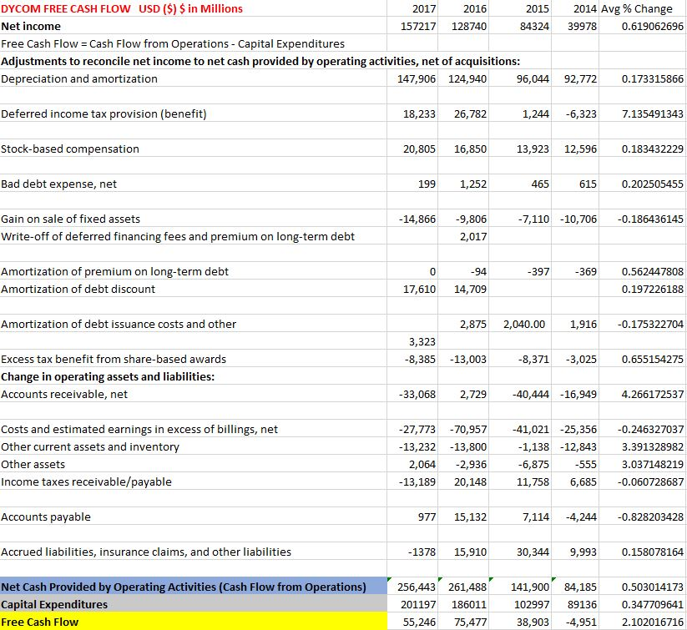

Figure 3:
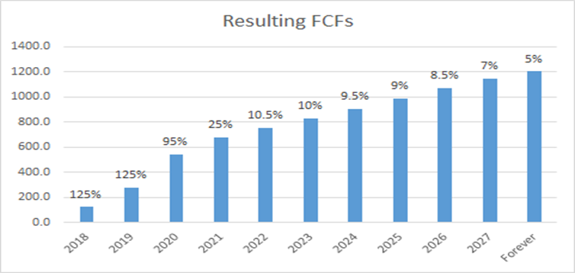
(Cash flows in millions)

Investment Risk

There are investment risks when it comes to Dycom as there are for any firm. As Dycom is very dependent on these large telecommunications companies for a majority of its business they are left open to risk through these companies. If one of their large customers like AT&T or Verizon were to decide to begin handling more of its wireline installation in house that would hurt Dycom rather seriously. Another possible risk would be if Dycom can not keep up with the demand of these telecommunications companies as 2020 draws closer. This would lead to strained relationships with these companies, which again would lead to negative results for Dycom. It would not hurt Dycom to try and grow a different sector of their business more, so they would be less reliant on telecommunications giants for their success. The last major risk they are open to would be the possibility of being acquired by a different larger firm. At this time there is no sign that this will happen but in the future circumstances may change in this could become a possibility.

Conclusion

Through our valuation model, as stated above, we believe the market is undervaluing Dycom at this time. With our model showing a share price of $133.31 and shares currently trading for around $109 we recommend buying more shares of Dycom. The market is not accounting for the massive growth that Dycom will undergo in the next few years as 5G rolls out, and now is the time to take advantage of this underpricing.

