TPI Composites Analysis

Winona State University

Lorraine Christianson
Xin Zhou

Company Snapshot

TPI is the largest manufacturer of composite wind blades in the United States. They are part of the high-growth global wind energy market and have composite production facilities in North America, Europe and Asia. Some basic information about the company is listed below.

- Traded on the NASDAQ as TPIC
- Sector: Wind energy, transportation, manufacturing
- Industry: Industrial Machinery/Components
- Date Founded: 1968
- Date went public: July 2016
- Revenue: $585.9M
- Market Cap; $653.91M
- Stock Price, April 28th; $19.65
- 1-year target: $ 24.00
- Headcount: 5,600
- Headquarters: Scottsdale, AZ

Investment Summary

It is our recommendation to buy or hold TPI stock. We believe that right now the stock is undervalued and not fully recognized for its potentially. Alternative energy is the future. It is not being pushed by the current federal administration, but eventually it will be. State government have already started to push it. Every state requires between 15-50% of the total energy consumption to come from alternative sources. TPI is positioned to grow with the market. They have already begun to prepare for future demand.

TPI went public this past July. Their stock price has remained constant for the majority of the time since. This past October their stock did drop slightly due to one of their customers, General Electric Company, bought out one of our competitors, LM Wind energy. This buyout caused GE to cancel some of their contract with TPI - but not all of them.

Aside from this TPI is making headlines for, “TPI and Vestas sign Wind Blade supply agreement for Latin America”, “TPI Composites expands its relationship with Gamesa and signs new supply agreement in Turkey”, and “TPI Composites, Inc. Announces fourth quarter and full year 2016 Earnings Results”.

Business Description

TPI has been producing wind blades since 2001. Their products excel where high strength, light weight and durability are required. They have over five decades of innovation and expertise in manufacturing large-scale composite structures of highest quality at competitive prices.

TPI’s advanced composites manufacturing technology allied towards building military vehicles allows them to build near aerospace grade parts at industrial prices. TPI's expertise has also been applied to create first-of-their-kind composite solutions in the transportation markets.They are currently working on what is descripted as the Tesla version of public busing transportation. TPI also has the ability to produce the parts needed to build rides at amusement parks.

For now TPI is focusing on these products. Wind Blades are responsible for 99% of the revenue. And the other products make up the remaining 1%. The main expense for the company is research and development.

Management & Governance

Name Age Position
Steven C. Lockard 55 President, Chief Executive Officer and Director
Mark R. McFeely 44 Chief Operating Officer
Wayne G. Monie 68 Chief Manufacturing Technology Officer
William E. Siwek 54 Chief Financial Officer
Lars Moller 49 Executive Vice President—Business Development and Strategy
Thomas J. Castle 45 Senior Vice President—North American Wind Operations and Global
Operational Excellence
Steven G. Fishbach 47 General Counsel and Secretary

Industry Overview and Competitive Positioning

The wind blade market is highly concentrated, rapidly growing, competitive and subject to evolving customer needs and expectations. Over the last three years it has grown at 25% annually. This added demand for alternative energy has made the composites market more competitive.
The main competitive factors in the wind blade market include reliability, total delivered cost, manufacturing capability, product quality, engineering capability and timely completion of wind blades. The wind energy industry is characterized by evolving customer demands. To remain competitive TPI must adapt quickly to customer requests for changes to wind blade specifications.
TPI is currently competing favorably with respect to all of these factors. They are seen as one of the top competitors.

Valuation and Financial Analysis

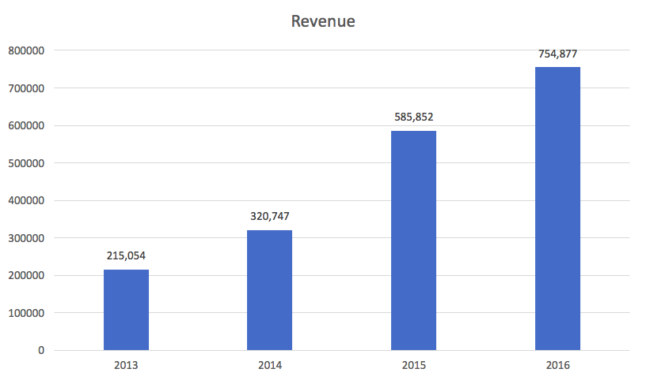

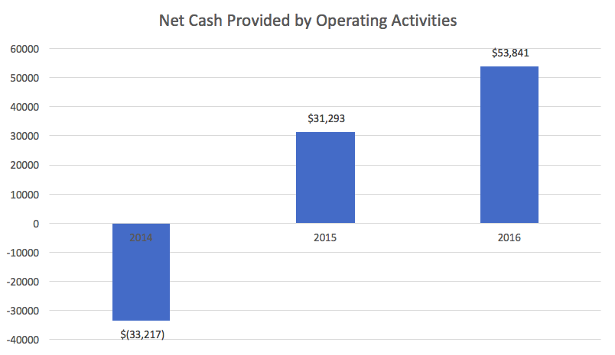

TPIC's current revenue is $754.88 million. Sale of NPTN has been consistently grown over past four years (current year: $754.88M, 2015: $585.85M,2014: $320.75M, 2013: $215.05M). Also cash flow from operating activities is positive and increasing over past three year. A positive cash flow is typically used for internal expansion, acquisitions, dividend payments, etc. A company that generates rather than consumes cash is in much better shape to fund such activities on their own, rather than needing to borrow funds to do so. TPIC's current operating cash flow is $53.84M and last year was $31.29M.
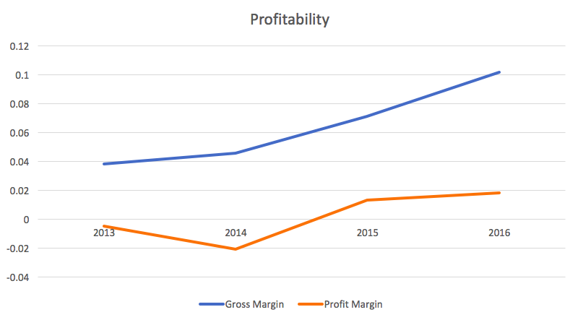

TPIC's profit margin has been consistent or even increasing over the past four years (Current year: 1.83%, Last year: 1.31%, Two years ago: -2.07%, Three years ago: -0.48%). It is a sign of good management and a healthy and competitive enterprise. TPIC's current profit margin is 1.83% indicating its competing in a low margin industry. Being cost effective and offering competitive price against rival is critical and determining that if they can sustain this up-trend of margin and compete favorably in industry.

TPIC’s gross margin has been consistently increasing over past four years (Current year: 10.20%, Last year: 7.13%, Two years ago: 4.57%, Three years ago: 3.84%). Companies use gross margin to measure how their production costs relate to their revenues. Consistently improved gross margin of TPIC indicating that firm’s management is doing good work on cost control and maintaining health business model. Gross profit, the first level of profitability, tells analysts how good a company is at creating a product or providing a service compared to its competitors. And better margin is providing more cash flow to cover operating expense.

TPIC has not significantly issuing new shares within recent years which is a good sign. TPIC currently has 34.0 million shares outstanding. This means the company is not taking any measures, with regards to the number of shares, that will dilute or devalue the stock.

Tax Consideration
 | 2013 | 2014 | 2015 | 2016
Tax | -3346 | 925 | 3977 | 6995
Effective Tax rate | 76.53% | -0.16% | 34.11% | 33.57%

TPIC's income tax paid expressed as a percentage of pretax income this year is 33.57% and last year was 34.11%, which are consistent. If the tax rate is below 20% could indicate that the earnings that were reported were unrealistically inflated due to the lower level of income tax paid.

Valuation summary:
Analysts expected one-year target stock price to be $24.00, with current stock price being $19.65. The recommendation is to buy or hold TPI stock. Analysis suggests that right now the stock is undervalued and not fully recognized for its potentially. Also there are several major analyst firm following buy recommendation including Cowen & Company, JP Morgan Security, Morgan Stanley, Raymond James and Roth Capital PA. This is providing credibility of investing in TPIC for other investors.

Investment Risks
The Company operates in a dynamic industry and can be affected by a variety of factors. Any of the following areas could be a potential risk for the Company:

- GE’s planned acquisition of LM Wind Power, TPIC’s largest competitor, resulting losing its strong partner and customer GE
- The results of the 2016 United States presidential and congressional elections has created regulatory uncertainty for TPIC’S business and the wind energy sector
- Defects in materials and workmanship or wind blade failures could harm company’s reputation, expose TPIC to product warranty or other liability claims
- Changing customer demands, business focus and strategy in wind blade industry and associated transition costs
- Currency, legal, regulatory, economic, social and political risks associated with company’s global operations and those in developing markets since a substantial portion of operation are conducted in international markets
- Wind turbine OEMs may not be holding the trend to shift from in-house production to outsourced suppliers
- Significant increases in the prices of raw materials or components that cannot be reflected in the price of products drives down company’s profit margin

Recommendation

It is our recommendation to buy or hold TPI Composites Stock. Analysts expected one-year target stock price to be $24.00, with current stock price being $19.65. Also, there are several major analyst firm following buy recommendation including Cowen & Company, JP Morgan Security, Morgan Stanley, Raymond James and Roth Capital PA. We believe that right now the stock is undervalued and not fully recognized for its potentially. Alternative energy is the future. It is not being pushed by the current federal administration, but eventually it will be. TPI is positioned to grow with the market. They have already begun to prepare for future demand.

