**Background Information**

Vascular Solutions (VASC) is an innovative medical device company in the healthcare industry and medical device sector that focuses on providing clinically advanced solutions to the market for treating coronary and peripheral vascular disease. Vascular Solutions primary stock exchange is the NASDAQ and has a current stock price of $54.40 (DATE) with a Market Capitalization of $981.9 million. Major shareholders consist of BlackRock, Inc., Neuberger Berman LLC, Conestoga Capital Advisors, LLC, The Vanguard Group Inc., and RBC Global Asset Management Inc. The liquidity position of the firm is relatively high with a (TRADE VOLUME OF)(STABLE THROUGH 2008) Our investment recommendation for VASC consists of a conditional buy given that the stock price declines to the target stock price of $44.54 which reflects the fair price given the risk of the growth opportunities.

**Investment Summary**

Vascular Solutions, a medical device company that focuses on providing clinically advanced solutions to the market for treating coronary and peripheral vascular disease has had recent developments such as a cooperative development agreement with the U.S. Army to create RePlas Freeze-Dried Plasma which was submitted October 18th, 2016 and has a target commercialization date between 2019-2020. The recent development is projected to have an opportunity of revenue above $100 million. Another recent development that has occurred is the resolution of unwarranted criminal allegations regarding off-label promotion of the product Vari-Larse Short Kit Varicose Vein Treatment device which accounted for .1% of revenue and never harmed a single patient. Total duration and costs of litigation amounted to five years and $25 million in costs. The recommended course of action for VASC is a conditional buy given that the stock price decreases to the target price of $44.54. Our reasoning behind the overvaluation of the stock lies upon the market mispricing of the growth opportunities in the future to come such as the underestimation of specific risks including FDA approval, research and development conversion rate, market movement into the industry of consolidation buyers, and the declining of interventional catheter market.

**Business Description**

Vascular Solution (VASC) is a medical device company that delivers proprietary clinical solutions for diagnosing and treating vascular conditions (Annual Report). VASC was incorporated in 1996 and began operations in 1997 in Delaware. They went public in 2000 (specific date?) and are currently headquartered in Minneapolis, MN. VASC sells products to address four primary markets: Interventional Cardiology, Phlebology, Electrophysiology, and Interventional Radiology. They sell their products both domestically, through a direct sales force consisting of 103 employees and 71% of their sales, and internationally, through an international distributions network which accounts for 29% of their sales. They are an R&D focused company that will also innovate outside of their proprietary R&D through relationships as a developer, distribution partner, or acquirer with partners who have product ideas but do not have the necessary resources or capabilities to develop their product. As of 2015 VASC’s best-selling product is the GuideLiner catheter, which accounts for $45.4 million of their net revenue. They’re other best-selling products are the Pronto catheter ($14.9 million), Vein catheter reprocessing ($12.6 million) and

VASC finds its competitive advantage in its rapid product development, by launching approximately 100 new medical devices since being incorporated and having more than 40 new product ideas currently in development. Part of their strategy is to find the underserved markets that the larger companies in the industry aren’t paying attention to and evaluate those underserved markets to find if this would be a good segment of the market for growth.



Micro-introducer kits ($12.3 million). One of VASC’s biggest prospects is their agreement with the United States Army to develop a product called RePlas, which is freeze-dried plasma that can be used as treatment for battlefield trauma. They a have strategic alliance with another company, a bio-med engineering company called Amnis Therapeutics Ltd. (AMNS.M), in which VASC agreed to be responsible for all communications with the FDA and the clinical studies in the United States for AMNS.M’s Aneugraft Dx coronary covered stent.

VASC finds its competitive advantage in its rapid product development, by launching approximately 100 new medical devices since being incorporated and having more than 40 new product ideas currently in development. Part of their strategy is to find the underserved markets that the larger companies in the industry aren’t paying attention to and evaluate those underserved markets to find if this would be a good segment of the market for growth.

**Management and Governance**

Vascular Solutions executive management team has an all equity capital structure and does not plan on issuing debt now or in the near future to come. Executives have a performance based pay and the compensation package consists of three elements such as the base salary which mirrors individual performance and is designed to be competitive within the healthcare industry salaries, bonus payments which are contingent upon completion of specific corporate and individual objectives, and long term stock based incentives which align shareholders wealth with executives. Senior Management has a succession plan as well in order which calls for frequent meetings each quarter in regards to the status of operations and compliance programs.

**Industry Overview and Competitive Positioning**

*Medical Device Industry Background*

VASC is a part of the Medical Device industry. The U.S Device industry is the global leader with $136 billion in revenue in 2014 which accounted for about 50% of the global market. VASC is in the “stents and catheters” segment. The Medical Device industry is segmented into seven segments and an “other” segment. The segments are: Orthopedic Instruments, Surgical Instruments, Diagnostic Apparatus, Stents and Catheters, Syringes and Hypodemic Needles, Blood Transfusion and IV Equipment, Dental Instruments, and Other. The industry landscape is becoming increasingly consolidated with the biggest companies acquiring small start-up Medical Device companies. This has created an opportunity for small and medium sized Medical Device companies to address niche markets that the large companies don’t pay attention to.

*Industry Demand Driver and Growth Outlook*

The things that continue to drive the Medical Device industry are technological innovation and growth through acquisitions. The industry is becoming consolidated and fragmented at the same time. The large companies, Johnson & Johnsons (JNJ), are buying up the smaller startup companies, while mid to small sized companies are addressing the niche markets that the large companies can’t or won’t.

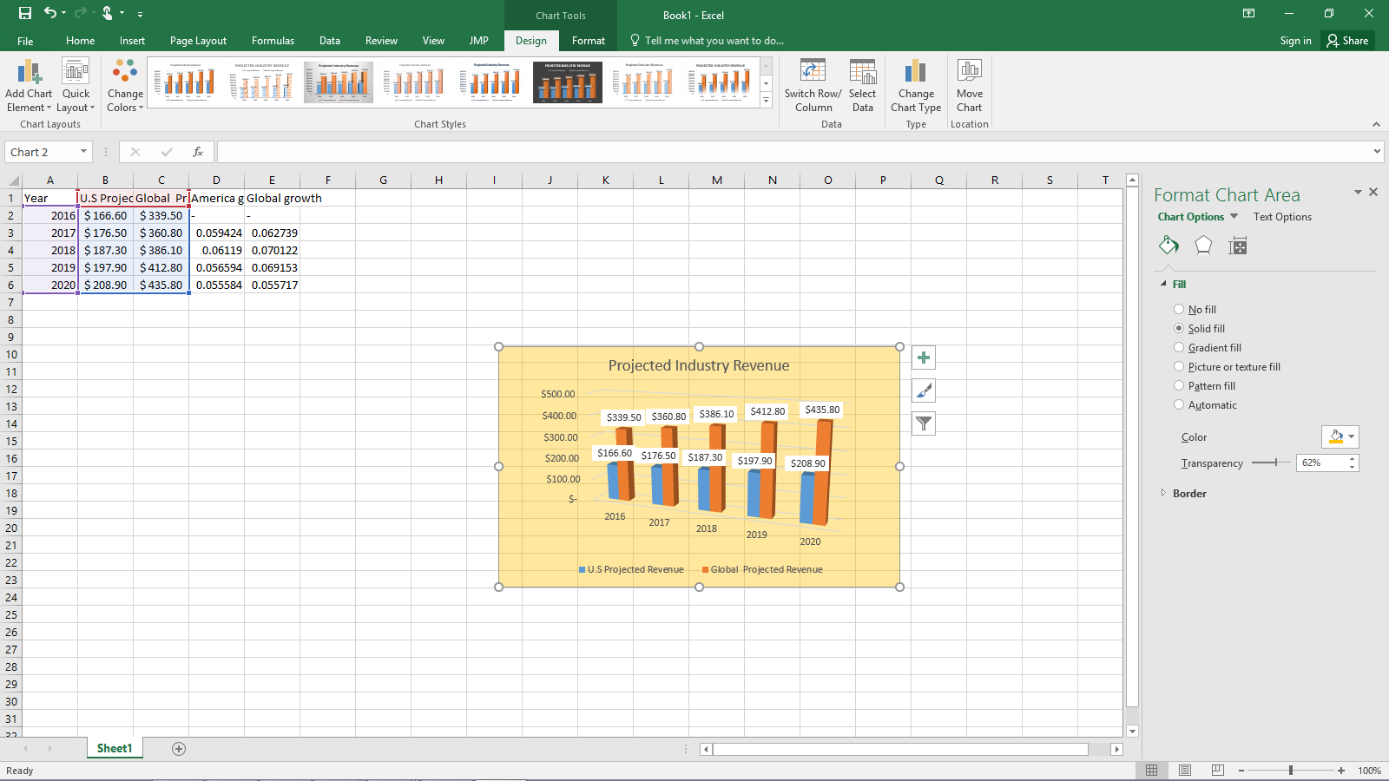

Source: Worldwide Medical Devices Forecast to 2020

As for industry demand drivers, they are imbedded in macroeconomic trends. The demographics of the United States and global population are becoming increasingly older. With advancements in medical technology the life expectancy rates have been climbing. That, accompanied with the fact that the average and median age is continuing to trend upwards, creates an environment where medical devices are becoming highly sought after. Excluding demographic trends, medical devices typically tend to be mostly inelastic, even in times of macroeconomic crisis.

The growth outlook for the Medical Device industry looks very strong. Combining an aging population with the demand for technological innovation creates an environment with great growth prospects. According to a report done in 2014 by Espicom, the U.S medical device market is expected to grow at an annual growth rate of around 6% between 2014-2017.

*Competitive Landscape and Positioning*

Using Porter’s Five Forces framework we determined that the competitive landscape of the Medical Device Industry is intense, but we would argue it is less intense for the niche companies like VASC. We deemed the threat of substitutes to be low because the patent protection given to Medical Device companies. When we looked at the threat of new entrants we also deemed this low, the capital requirements for the Medical Device industry is quite large. When we look at inter-industry firm rivalry the top players (Johnson & Johnson, General Electric Co., Medtronic Inc., Baxter International Inc.) are very competitive although they don’t compete directly with VASC. The bargaining power of the suppliers is pretty high for VASC because their contract with King Pharmaceutical expires in 2017 and that is where VASC gets the majority of their supplies. The bargaining power of buyers (as in physicians and hospitals) has generally been low, but with the recent trend of individual physicians wanting to work for big hospitals we decided that the bargaining power of buyers was starting to become larger.

Because VASC is a company that specialized in niche markets that are missed by others in the Medical Device industry the selection of comparable companies is small. The companies that are comparable to VASC are Endologix Inc (ELGX), a company that develops, manufactures, markets, and sells medical devices for the treatment of abdominal aortic aneurysms, ATRION CORP (ATRI), a medical device supplies company that sells fluid delivery devices along with ophthalmic and cardiovascular products, The Spectranetics Corp (SPNC), a medical device company that develops, manufactures, markets, and distributes single-use devices, and Antares Pharma Inc. (ATRS), a specialty pharmaceutical company focusing on parenteral pharmaceutical products and technology.

VASC’s comparable companies shouldn’t necessarily be considered their competitions. They are comparable companies because they are also niche market Medical Device companies with similar market capitalization sizes, but their niche market isn’t the same as VASC’s. VASC’s biggest competitors are companies who compete in their same markets, these competitors are: Medtronic plc. (MDT), manufacturer and distributor of medical therapies, Boston Scientific Corporation (BSX), an interventional medical specialty company, Merit Medical Systems, Inc. (MMSI), an interventional and diagnostic medical device company, and the Abbott Vascular division of Abbott Laboratories (ABT),

which directly competes in the cardiovascular market with VASC.

*Industry Supply*

The medical supplies industry is not oversaturated, and with a mixture of industry consolidation and small and medium niche market companies, accompanied with our expectations of medical device demand and industry growth, the expectation is that the medical device industry will not become oversaturated or move to its mature stage until at the least after 2020. Because this industry is driven by innovation and technological advancements, we are willing to argue that the industry may never become oversaturated.

**Valuation**

The absolute value that we assigned to VASC’s stock was $44.54. We acquired this absolute valuation through a Discounted Cash Flow analysis of VASC’s Free Cash Flows. Our model projected cash flows through 2025 with varying growth rates.

Our model focused mostly on the growth of future revenue. We determined the growth rate of future revenue using multiple methods. The first method we used was looking at analyst growth estimates and VASC’s growth estimates. This gave us a good idea of what the market was expecting for VASC’s revenue growth and allowed us to build a model around it. The second thing this allowed us to do was allow us to see if we agreed with the markets growth prospects, and if the DCF with that growth rate valued the company the way the market valued the company.

We adjusted the growth rate to be less than what the market was expecting because we believe the market was overvaluing the growth opportunities that VASC has. There was also a behavioral problem with the growth estimates, as we believe that because the CFO used to work as a stock analyst on VASC’s stock for Morgan Stanley he very well (directly or indirectly) could affect the growth estimates of other analysts. Even if the analysts disagreed with the growth prospects that VASC was portraying, they probably made a change in growth relative to VASC’s estimates because that’s how our brain works. This would most likely leave the analysts overestimating VASC’s growth prospects.

We capitalized R&D over a 10-year amortization period because pharmaceutical companies have seven year minimum patents and we thought 10 years would be a good estimate for how long R&D pays off. We also took VASC’s forecast for falling capital expenditures and decreased capital expenditures in the future for our DCF model.

After making the adjustments to growth, capital expenditures, and Research & Development our valuation of VASC’s stock came to $44.54. At the time, VASC’s stock was $54.35 so we would give VASC a conditional buy at $44.54. We believe that the market overpriced VASC’s stock because of a multitude of behavioral science factors pertaining to the estimation of future revenue growth for VASC. The markets valuation of VASC has their revenue growth sitting at around 20% and we don’t believe that to be an accurate estimate of revenue growth.



**Financial Analysis**

*Critical adjustments*

Before evaluating the performance of Vascular Solutions, we made a key adjustment to VASC’s financial statement to make them more representative of their true economic performance. We adjusted the firm’s investment in Research & Development (R&D). This adjustment removes yearly R&D expense from Income and considers it an investment on its balance sheet. The capitalization of R&D assumes the firm will at some point benefit from their investment at a later date. VASC has significant investment in R&D. The continued investment in R&D is critical to the firm’s growth. As a percent of revenue, R&D has historically been approximate 16%. The results of these investments are 10 new products a year. In 2015 VASC spent $24.7 million on R&D. To maintain the same level of growth VASC we predict R&D investments will grow at a simple 19.3% year-to-year. In other words, there will need to be a continual development of 10 products a year. This is feasible due to a strong pipeline of 40 products.

*Growth driver*

VASC’s revenue has grown at above average rate of growth compared to the medical device industry. Year-over-year VASC’s revenue has grown 17.14% compared to the medical device industry at 6.1%. We forecast VASC’s revenues to grow at similar rates to the year 2020. Factors that contribute to unusually high growth are: specialized sales team, niche market, heavy investment in R&D, and vertical integration. Currently VASC manufactures all their products and receive a gross margin of 66%. This directly contributes to the earning power of VASC. Although in 2020, VASC will need to restructure their business model to accommodate for sustainable growth. Based on our estimates, revenue will grow at 8% after the year 2020. This is still above industry average, but based on VASC competitive advantages there is a strong likelihood they will sustain 8% growth for the duration of our model ending in 2025. As the company matures, we believe that growth will taper off to slightly above industry average. As a manufacturer, the company maintains a substantial gross margin of 66%. We do not expect this to change in the future.

*Capital structure*

The firm carries no long-term debt (LTD) which reduces their nonmarket risk. With not LTD investors are willing to pay premium to acquire partial ownership in the company. Evidence of investor enthusiasm capital structure is seen in the firms above average Price-to-earnings value of 79.07. Price of VASC is influenced by the wiliness of investors to purchase the company’s stock for reason of growth, capital structure, and profitability. When evaluating earnings, which were $.61 per share in 2015, it is clear that the investors are paying a significant premium on the firm’s ability to realize the future growth opportunities and not its current earnings.

With no long-term debt obligations, the company is able to maintain a strong liquidity. This is measured by the firm’s current ratio of 6.4 times. A negative factor of not having any LTD is a higher cost of capital. Currently the firm’s weighted average cost of capital (WACC) is 7.36%. It is this high because the required rate of return investors anticipate is higher than the cost of debt. Therefore, the firm is no benefiting, besides reducing risk, from no financial leverage.

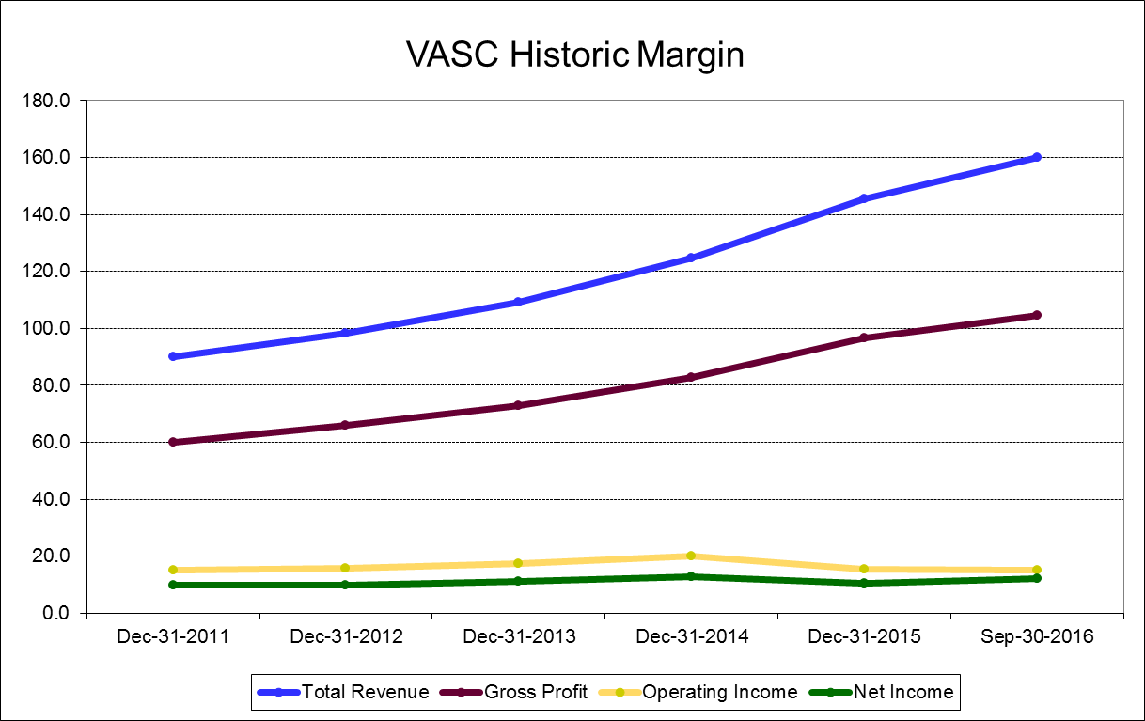

**Investment Risks**

*Decline in the Number of the Catheterized Procedures*

VASC alludes to the fact that they see a plateau in the number of catheterization procedures in the coming years. If this plateau turned into the decline in the number of catheterization procedures, our assessment of the target price of VASC would vastly overvalue the company. Four of VASC’s top eight products are a version of a catheter, so a slowdown would directly and fiercely affect their revenue growth.

*Litigation and FDA Approval Issues*

VASC has had litigation issues in the past and with the claimed *whistleblower* regulatory environment that is surrounding the Medical Device industry, VASC could be the target of one or several more lawsuits. If VASC is prone to a number of future lawsuits this would affect their capital expenditures on external acquisition and will in turn hurt the growth of their future cash flows.

One of VASC’s biggest growth prospects is their cooperative development agreement with the U.S Army to develop Freeze-Dried Plasma. Unlike most of VASC’s products, which do not need FDA approval, RePlas will need to be FDA approved. There is a long process for obtaining FDA approval and if something were to go wrong at any stage of the process they could lose significant cash flows.

*80% of Vascular Solutions Revenue Comes from a Concentrated Number of Products*

Around 80% of Vascular Solutions revenue comes from eight products. This amplifies the importance of the revenue that each of the products generate. If one or more products don’t continue to grow at the level we expect then we would foresee a significant drop off in the overall revenue of VASC. This would in turn effect cash flows to create a scenario where our target price is much higher than what VASC is worth in future cash flows.

*Bargaining Power of Buyers and Suppliers*

Vascular Solutions indicates that their U.S Direct Sales Force is one of their biggest competitive advantages. With the medical industry trending towards physicians wanting to work for larger hospitals, the number of buyers could consolidate. If the number of buyers becomes consolidated, VASC could lose some, if not most, of its competitive advantage and we would see a drop off in future cash flows. It would also amplify the importance of the U.S Direct Sales Force because the loss of one buyer would have a significant effect on total revenue.

A large amount of VASC supplies comes from King Pharmaceutical, with whom they have an agreement until 2017 to obtain the key components they need for their medical supplies (including Thromben for their Hemostat patches). There is a chance that King Pharmaceutical and VASC won’t be able to re-up after 2017. This would create, at least, a significant single time cost for VASC from trying to find and approved a new supplier. It could also affect future cash flows as they may not be able to acquire these key components at the price they were able to with King Pharmaceutical.

