Larry Schrenk, Instructor
Problem Set: Bond Valuation Problems
(Solutions Below)
Bond Valuation Problems
1. What is the price of the following bond?
face value: $1,000
maturity: 10 years
coupon rate: 8%
discount rate: 9%
2. What is the price of the following bond?
face value: $1,000
maturity: 50 years
coupon rate: 10%
discount rate: 12%
3. What is the value of the following semi-annual bond?
face value: $1,000
maturity: 10 years
coupon rate: 10%
discount rate: 9%
4. What is the value of the following semi-annual bond?
face value: $1,000
maturity: 9.5 years
coupon rate: 7%
discount rate: 7%
5. What is the value of the following semi-annual bond?
face value: $1,000
maturity: 20 years
coupon rate: 9%
discount rate: 10%
6. What is the price of the following quarterly bond?
face value: 1,000
maturity: 10 years
coupon rate: 10%
discount rate: 8%
7. What is the price of the following semi-annual bond?
face value: $1,000
maturity: 10 years
coupon rate: 8%
discount rate: 9%

Solutions
1.
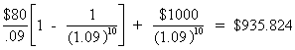
2.
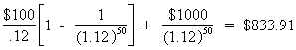
3.
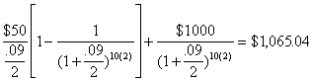
4.
Since coupon rate = discount rate, this must be a par value bond, and the price is $1,000, or…
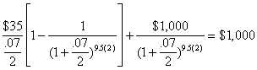
5.
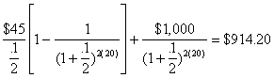
6.
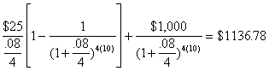
7.
